Table of Contents

Funding Sources 1

Challenges and Needs 4

Members typology 4

Partnerships and Collaborations 4

# 1.Funding Sources

## How have the primary funding sources for organizations evolved between the two surveys?

## Have there been significant shifts in the proportions of funding from government grants, private donors, corporate sponsorships, or other sources?

***Is there any correlation between the evolution of turnover and sources of funding?***

According to the findings, institutional donors are the most frequent contributors across all budget categories. This means that there is no direct relationship between a company's budget and its funding sources. However, findings show an increase in the proportion of organizations in the "£500,001 - £2,000,000" category. Furthermore, the proportion of funding obtained from institutional donors and sub-grants increased significantly, but the proportion of commercial revenue decreased.

# Challenges and Needs

***Have there been changes in the main challenges or needs expressed by these organizations over time?***

The analysis is available only for 2023 year

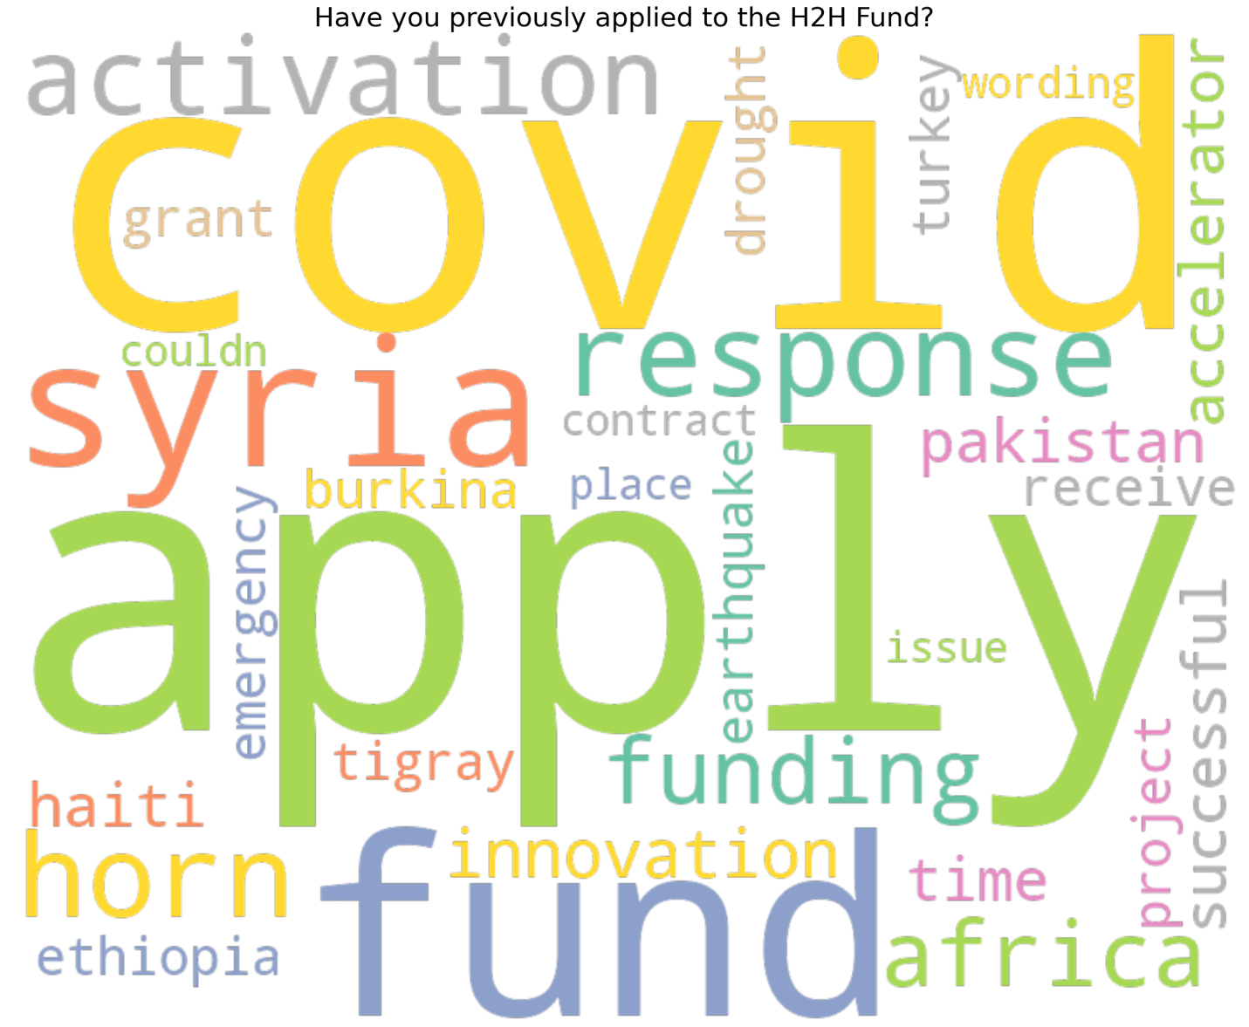

# Members typology

***Changes in composition***

***Are there any noticeable changes in the types of organizations participating in the surveys***

***Age of organizations***

***Legal status***

***Turnover***

***Number of employees***

***Volunteers***

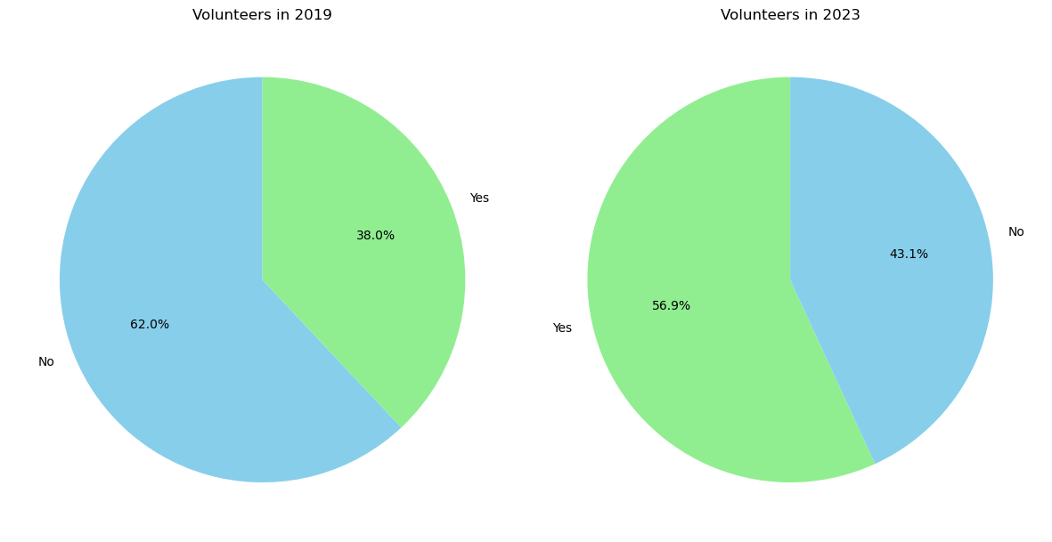

***Are our members still predominantly located in the Global North?***

***Are we seeing an evolution in terms of deployment/working remotely?***

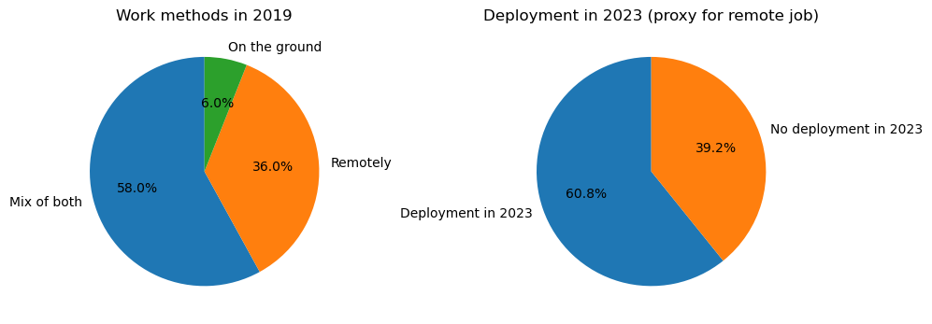

***The COVID-19 pandemic could explain why.***

The organizations have been involved with the H2H Fund, as evidenced by mentions of 'apply' and 'funding'. The presence of 'covid' suggests a significant connection between the fund and COVID-19 response activities. Furthermore, specific geographical references such as 'syria,' 'horn,' 'africa,' 'haiti,' 'pakistan,' 'ethiopia,' 'turkey,' and 'burkina' indicate diverse geographical involvement in relation to the projects associated with this area. The terms 'activation,' 'innovation,' 'accelerator,' and 'emergency' all allude to different types of responses or programs supported by the fund, which could include interventions during crises such as earthquakes or droughts.

# Partnerships and Collaborations

***How have collaboration patterns or partnerships among organizations evolved over time?***

***Are there new trends in collaborations with other entities or sectors?***

# Services end user

***Is there an evolution between the 2 surveys in the type of end users?***

